Wearables
# Source: Chatgpt (GPT-5-Mini) at [1/23/2026]
Wearables (short for wearable technology) are electronic devices that you can wear on your body. These devices are designed to offer convenient, hands-free access to digital information, often for health, fitness, or communication purposes.

Wearables photo
# Source: Windows Screenshots (using Lightshot Program) at [1/23/2026]
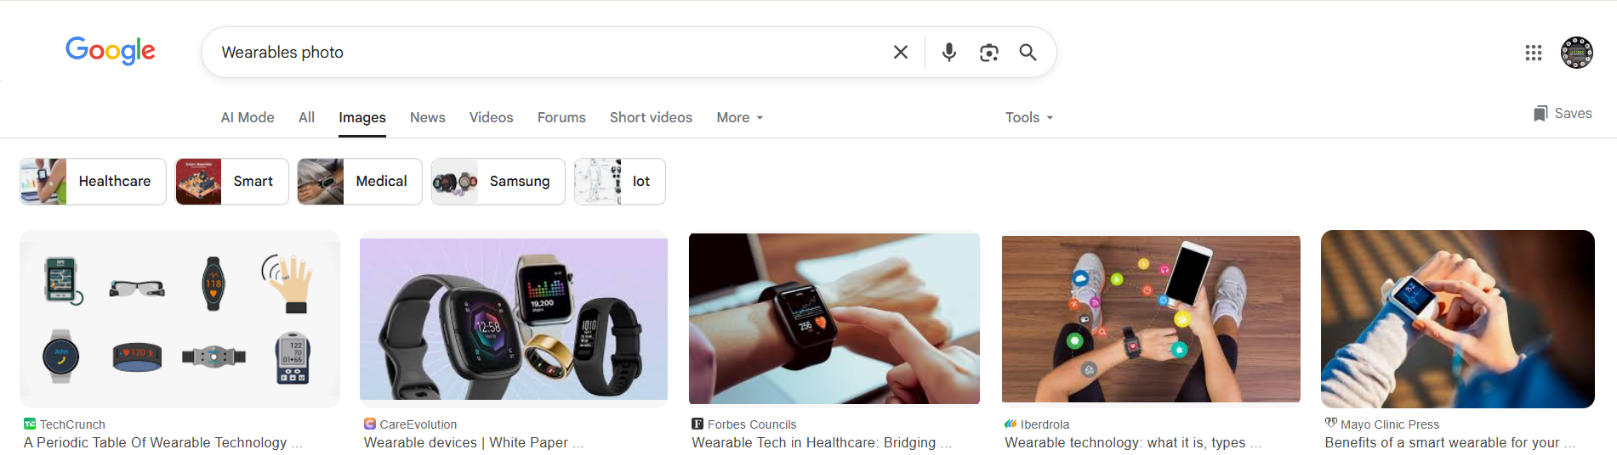

# Source: [Data Path: Miscellaneous Folder -> Miscellaneous Database -> Miscellaneous Table -> ID: 34] at [1/23/2026]
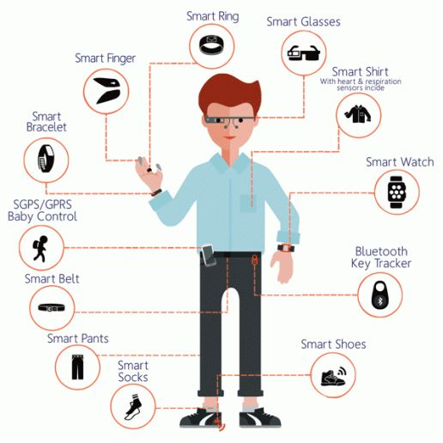

🔑 Key Features of Wearables:
# Source: Chatgpt (GPT-5-Mini) at [1/23/2026]
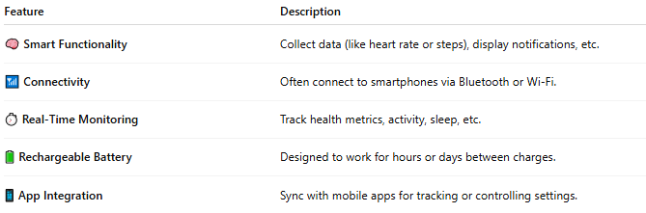

Feature | Description
🧠 Smart Functionality | Collect data (like heart rate or steps), display notifications, etc.
📶 Connectivity | Often connect to smartphones via Bluetooth or Wi-Fi.
⏱️ Real-Time Monitoring | Track health metrics, activity, sleep, etc.
🔋 Rechargeable Battery | Designed to work for hours or days between charges.
📱 App Integration | Sync with mobile apps for tracking or controlling settings.

🧩 Common Types of Wearables:
# Source: Chatgpt (GPT-5-Mini) at [1/23/2026]
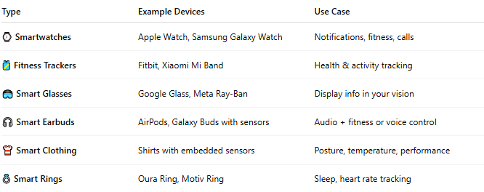

Type | Example Devices | Use Case
⌚ Smartwatches | Apple Watch, Samsung Galaxy Watch | Notifications, fitness, calls
🎽 Fitness Trackers | Fitbit, Xiaomi Mi Band | Health & activity tracking
🥽 Smart Glasses | Google Glass, Meta Ray-Ban | Display info in your vision
🎧 Smart Earbuds | AirPods, Galaxy Buds with sensors | Audio + fitness or voice control
👕 Smart Clothing | Shirts with embedded sensors | Posture, temperature, performance
💍 Smart Rings | Oura Ring, Motiv Ring | Sleep, heart rate tracking

📱 Wearables vs Smartphones:
# Source: Chatgpt (GPT-5-Mini) at [1/23/2026]
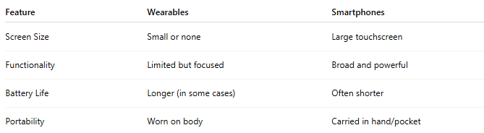

Feature | Wearables | Smartphones
Screen Size | Small or none | Large touchscreen
Functionality | Limited but focused | Broad and powerful
Battery Life | Longer (in some cases) | Often shorter
Portability | Worn on body | Carried in hand/pocket

📖 Summary:
# Source: Chatgpt (GPT-5-Mini) at [1/23/2026]
Wearables are smart electronic gadgets you wear that help track your health, keep you connected, or enhance real-world experiences. They’re part of the Internet of Things (IoT) and are becoming more popular in fitness, healthcare, and everyday life.

